Shopping Management System

|  |  |
| --- | --- |
| **Subsystem** | **Owner** |
| Product management subsystem | Quan Yang |
| Price management subsystem | Quan Yang |
| User management subsystem | Huynh Truong |
| Inventory management, warehouse management subsystem and Log management | Yu Zhou |

# Product management subsystem

# 

# Price management subsystem

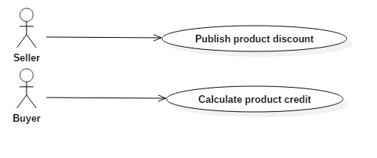

# User management subsystem



Some of key feature:

* Register
* Login
* Profile
  + Personal Information
  + Payment method
  + Promotion Customer type (Silver/Gold/Diamond)
* Buy
  + Shopping Cart / Order Items
  + Wish List (Subscription to some items)
  + History Buy
* Sell
  + Store with List of products
  + Can sell existing item on the system
  + Sell/ Create new items not in the system
  + Can set price for items
  + Percent fee paid according to category of item (5-20%)

**Description:**

This application will enable customers to buy products, as well as proceed checkout their shopping card toward make payment for their order. Also, they can track their order history if they have registered an user account in application. Moreover, they can update their profile, as well as update the payment information which includes credit/debit card information and shipping address.

When a customer first open Application, he/she views products from home screen. Products are organized follow category list. He/she adds products to their shopping cart and continue shopping or they proceed checking out. Also, Application will verify the product from stock whether these products are available.

Once the customer has completed choosing products, customers can proceed checking out their shopping cart. The Application also will look up the promotion information whether there are any discounts applying to products in this shopping cart. After that, customer can go to payment screen to complete their order by supplying the bank card information, as well as the shipping information.

Especially, customer will belong to different types Standard, Silver and Gold. When customer first register to the Application, their type is Standard. They can be promoted to another type depend on total amount of their order values in the history. He/she also will receive a discount percentage on next their orders in future.

1. Inventory management, warehouse management subsystem and Log management

Inventory management



Warehouse Management



Log system

